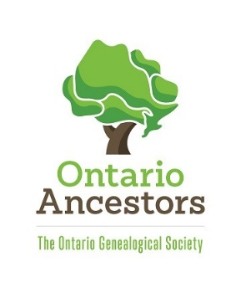

Application for a Position on the Board of The Ontario Genealogical Society

Position Sought: President, Vice-President, Director-at-Large (circle one)

OGS Number:

Full Name:

Full Mailing Address:

E-mail Address:

Primary Phone Number:

Secondary Phone Number:

Qualifications:
Describe your background, qualities and skills as they relate to the position sought. These may be gained from employment, self-employment or volunteer activities. (Please refer to items from the Call for Candidates and/or provide others of your choosing.

Vision:
Please provide three goals that you would like to see us achieve in the coming year, and explain how you could help address these goals based upon your expertise or energy.

References:
Supply the names, e-mail addresses and phone numbers of at least three (3) references. At least two (2) must be OGS members, at least one (1) must be a non-member. None should be immediate family members.

Email the completed application form to Patti Mordasewicz, Chair – Elections Committee, at elections@ogs.on.ca no later than March 23, 2020.

